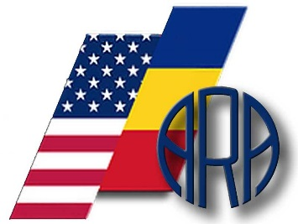
AMERICAN ROMANIAN ACADEMY OF ARTS AND SCIENCES (ARA)
Academy Headquarters: University of California, Davis,
One Shields Avenue, Davis, CA 95616
Mailing Address: PO BOX 2761, Citrus Heights, CA 95611-2761
E-mail: info@americanromanianacademy.org

PRE-REGISTRATION FORM FOR THE
43rd ARA CONGRES, Aristotle University of Thessaloniki, June 10-13, 2019
Congress website located on the ARA website: www.AmericanRomanianAcademy.org

Dear Colleagues,

Please fill out this Form and send it back to contact@AmericanRomanianAcademy.org, in MS Word document.
We welcome the receipt of presentations in the form of one-page abstracts, and after being reviewed, final articles, posters, contributions and presentations in the following Congress sections:

□ Anthropology
□ Art & Music
□ Biology
□ Chemistry
□ Computer Science
□ Economy
□ Engineering
□ Environment
□ History
□ Interdisciplinary Sciences
□ Law
□ Linguistics & Literature
□ Mathematics
□ Medicine
□ Politics & Philosophy
□ Physics
□ Social Sciences
□ Theology

Original paper OP □
Original scientific review OR □
Poster PO □
Oral presentation OP □

- Title of the presentation:...……………………….……………………….....................................................
- Author/Presenter Name: ……………………………………………………………………………………
- Scientific Title: ……………………………………………………………………………………………
- Institution / Former Affiliation:
……………………………………………………………………………………………………………
- Affiliation to ARA: □ ARA Full Member, □ ARA Emeritus Member, □ ARA Corresponding Member, □ ARA Affiliate Member, □ Non-Member, □ PhD student
- Address: Street number, ZIP Code, City/Town, Country: …………………………….…………………..
…………………………………………………………………………..………………………………….
- Phone (including country code): ……………………………SKYPE address…………………...................
- E-mail(s): …………………………………………………………………………………………………...
- I agree to give the publishing rights to ARA, on its web site, on line, with the associated DOI, and to complete the declaration of the author’s originality and sign the copyright form on the submission of the paper until May 10, 2019.
- I would like to Chair the following Congress section:………………………………………………………
- Are you interested in the Thursday trip (June 13, 2019)? □ Yes □ No
Possible itinerary includes: Salonic – Veria – Vergina – Kozani – Grevena – Metsovo – Meteora – Trikala – Larisa – Katerini – Salonic. We will keep you informed of the cost of the trip and other details.

Name ----------------------------------------------------

Signature:-----------------------------------------------

email: ----------------------------------------------------

Date: -----------------------------------------------------

